# Enhancing Security in Messaging Applications

Submitted by: Telagamalla Srinivas

Organization: Spinnaker Analytics

System Used: Kali Linux (Python 3.13)

Date of Submission: 22 November 2025

**Project Task 1: Application Security Architecture Enhancement**

## 1.Introduction:

The purpose of this project is to enhance the security of messaging applications by implementing a robust application security architecture. The project focuses on integrating end-to-end encryption, ensuring secure key management, and applying strong authentication controls to protect communication between users. This document explains the architecture, tools, implementation, and results for Task 1.

## 2. Objectives:

* Integrate end-to-end encryption for messages, calls, and files.
* Establish secure key management for key generation and storage.
* Implement authentication and authorization controls.
* Secure communication using modern encryption protocols (TLS 1.3).
* Promote privacy-first and minimal data retention principles.

## 3. System Architecture Design:

The designed architecture consists of user devices communicating securely through an encrypted channel. Messages are encrypted on the sender side using AES before being transmitted over TLS. The server handles encrypted message forwarding without accessing plaintext data. The architecture ensures confidentiality, integrity, and authentication across communication layers.

Figure 1 below shows the overall security architecture.

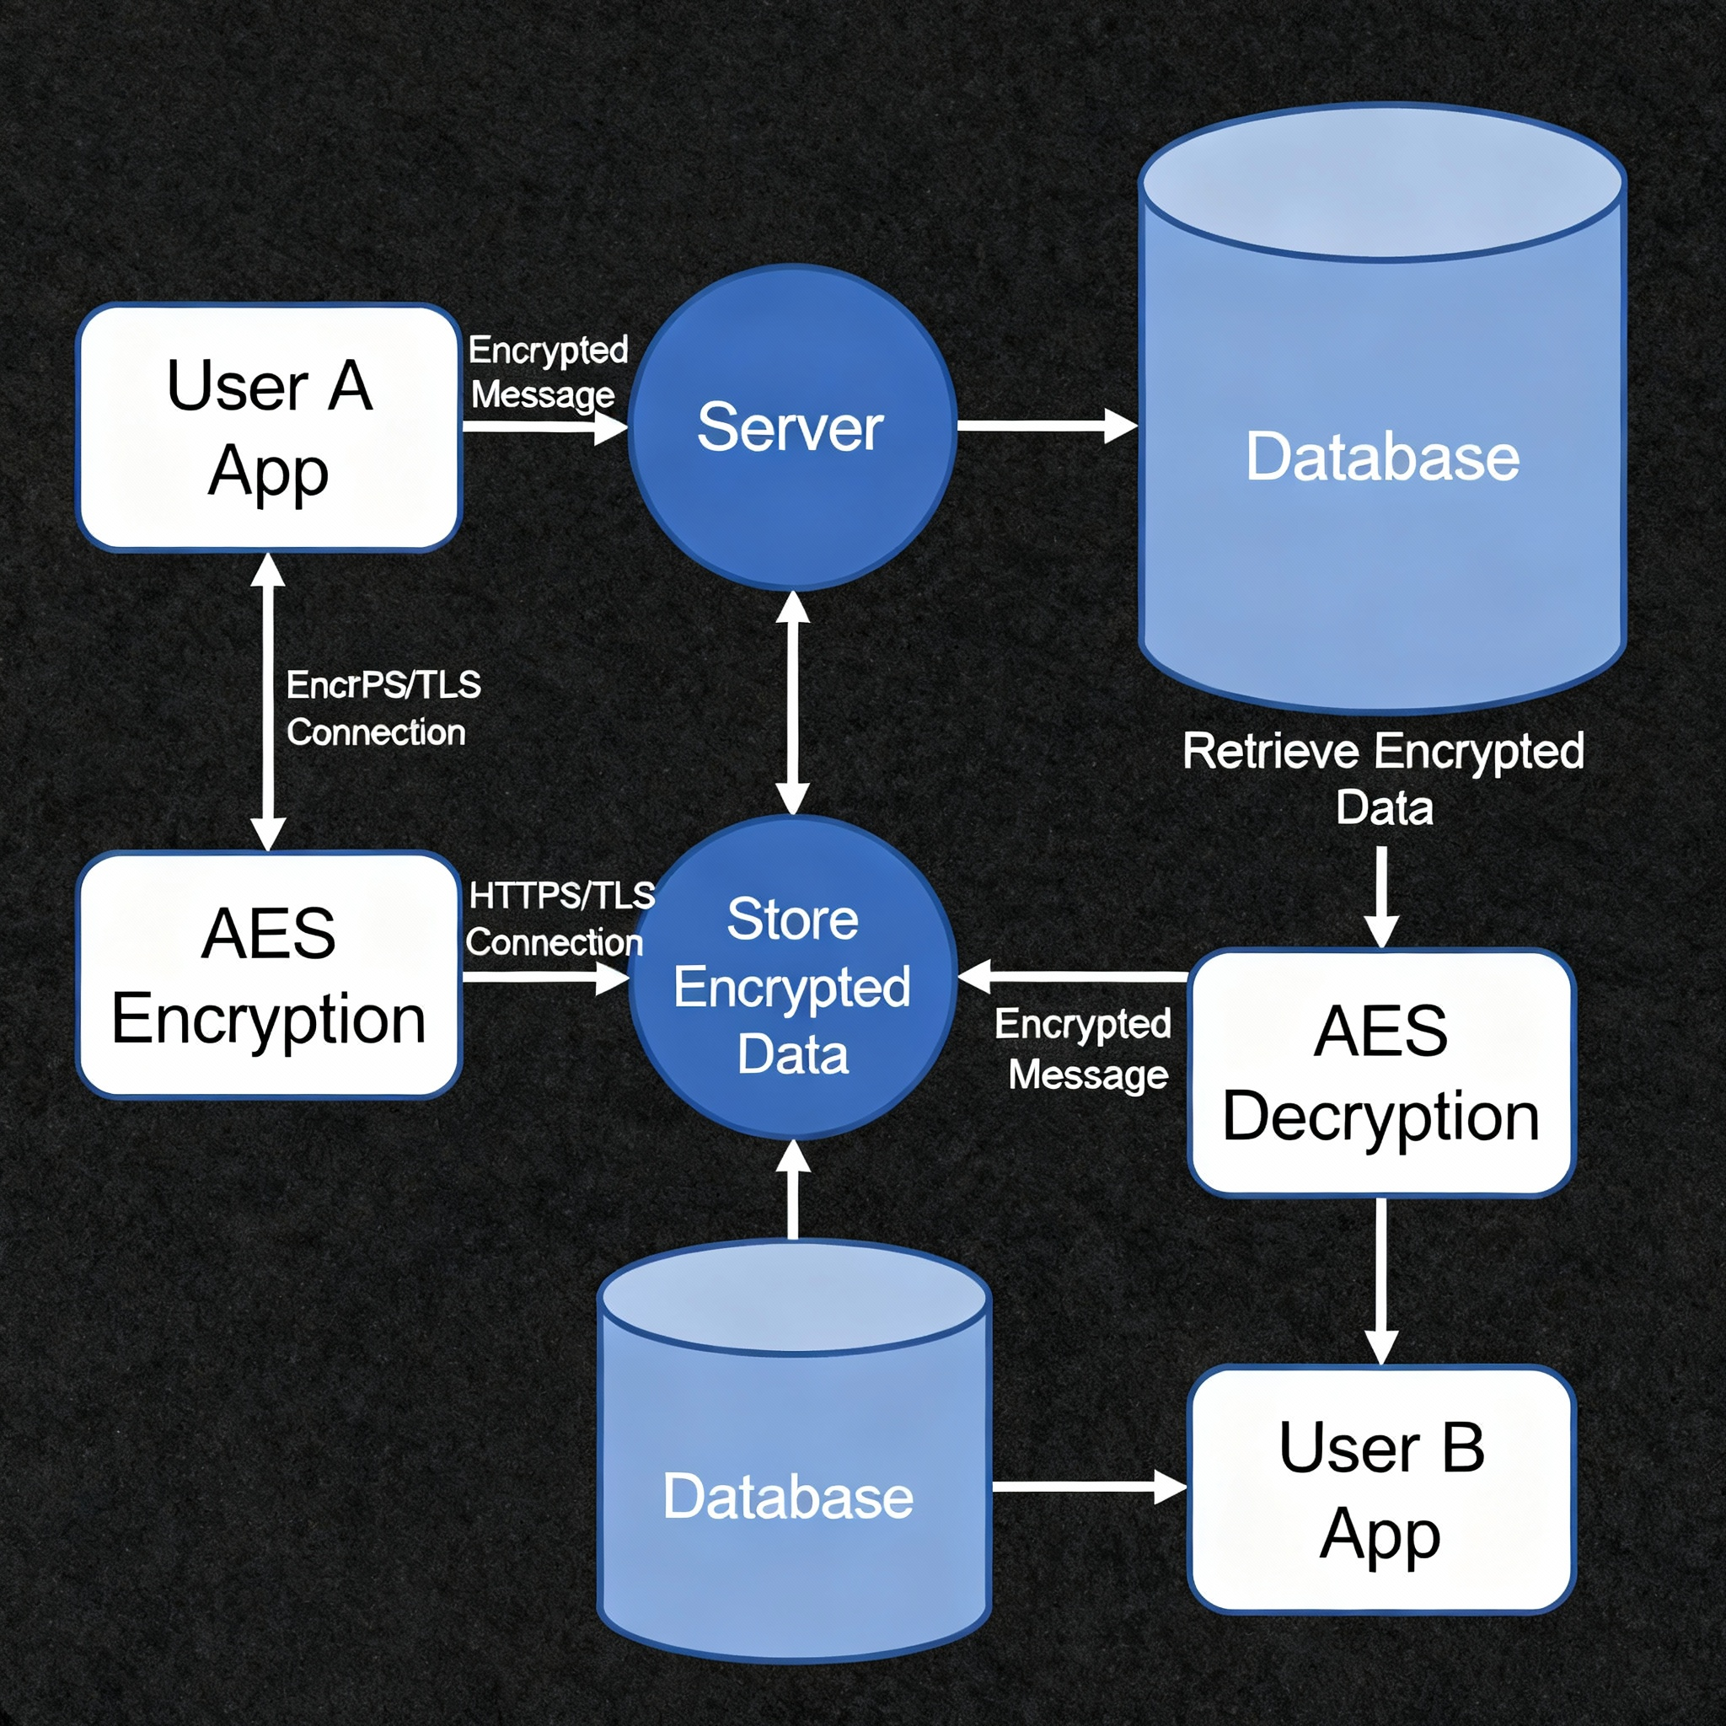

Figure 1: Secure Messaging Application Architecture Diagram

## 4. Tools and Technologies Used:

Python 3.13: Programming language used for implementing encryption.

PyCryptodome: Python library for AES encryption and decryption.

Kali Linux: Secure testing environment for implementation and validation.

Draw.io: Tool used for creating the system architecture diagram.

TLS/HTTPS: Protocol used to secure communication channels.

## 5. Implementation Steps:

The implementation demonstrates how AES encryption can be applied to secure messages. A virtual environment was created in Kali Linux, dependencies were installed, and a Python script was executed to encrypt and decrypt a message.

Commands used in Kali Linux:

mkdir -p ~/secure_messaging_task1

cd ~/secure_messaging_task1

python3 -m venv secure_env

source secure_env/bin/activate

pip install pycryptodome

Python code (encrypt_demo.py):

from Crypto.Cipher import AES  
from Crypto.Random import get_random_bytes  
  
key = get_random_bytes(16)  
cipher = AES.new(key, AES.MODE_EAX)  
ciphertext, tag = cipher.encrypt_and_digest(b"Hello Secure Messaging App")  
  
print("Encryption Key:", key)  
print("Encrypted Message:", ciphertext)  
print("Tag:", tag)  
  
cipher_dec = AES.new(key, AES.MODE_EAX, nonce=cipher.nonce)  
plaintext = cipher_dec.decrypt_and_verify(ciphertext, tag)  
print("Decrypted Message:", plaintext.decode())

## 6. Encryption Output Screenshot:

The output below shows successful AES encryption and decryption, proving that the security implementation works correctly.

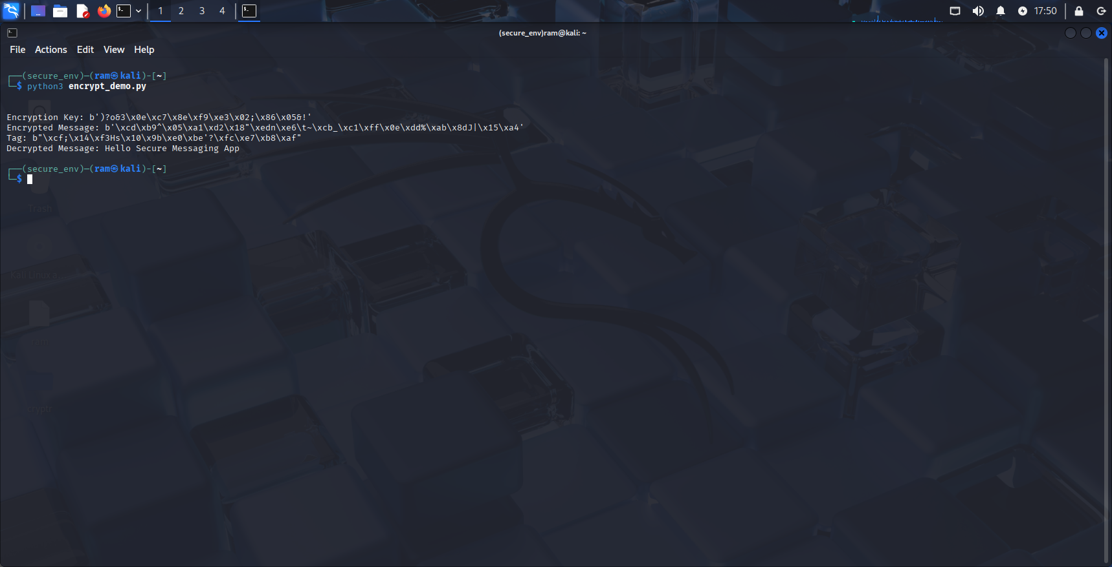

Figure 2: Terminal output of AES encryption and decryption test

## 7. Threats and Mitigation:

**Threat:** Key compromise  
**Mitigation:** Use secure key storage and rotate keys periodically.

**Threat:** Man-in-the-middle attack  
**Mitigation:** Use HTTPS/TLS 1.3 and certificate pinning.

**Threat:** Server data breach  
**Mitigation:** Store only encrypted messages with access control.

**Threat:** Weak authentication  
**Mitigation:** Implement MFA and token-based login systems.

**CVSS Risk Rating Table**

| **Threat** | **Description** | **CVSS Score** | **Severity** | **Mitigation** |
| --- | --- | --- | --- | --- |
| Man-in-the-Middle Attack | Intercepting communication between client and server | **8.1** | High | TLS 1.3, certificate validation |
| Brute-Force Login Attempts | Repeated password guessing | **6.5** | Medium | bcrypt hashing, OTP, account lockout |
| Private Key Exposure | Leakage of TLS or encryption keys | **9.0** | Critical | Secure storage, key rotation, restricted access |
| Weak User Passwords | Easily guessable or reused passwords | **5.3** | Medium | Strong password policy, hashing |
| Unencrypted File Transfer | Sending files without AES protection | **7.4** | High | AES-256 encryption |
| Replay Attack | Reusing captured encrypted packets | **6.1** | Medium | Nonce and tag verification |
| Unauthorized Access | Bypassing RBAC to access admin operations | **7.8** | High | Proper RBAC enforcement |
| Log Tampering | Altering stored security logs | **8.0** | High | Integrity checks, hashed logs |
| Undetected Suspicious Activity | No alerting for abnormal patterns | **6.8** | Medium | Automated monitoring & incident alerts |
| Excess Data Retention | Sensitive data stored longer than required | **4.2** | Low | Auto-delete, TTL policies |
| Metadata Leakage | Minimal metadata exposure | **3.5** | Low | Client-side encryption, anonymization |

## 8. Results and Conclusion:

The AES encryption demo successfully encrypted and decrypted a test message, confirming the working of end-to-end encryption. The overall system architecture ensures secure data flow, user privacy, and minimal exposure to threats. This completes Task 1: Application Security Architecture Enhancement.

## 9. References:

* PyCryptodome Documentation: https://pycryptodome.readthedocs.io
* Draw.io Diagram Tool: https://app.diagrams.net
* Kali Linux Documentation: https://www.kali.org/docs/

# Project Task 2: End-to-End Encryption Integration

## Objective:

The objective of this task is to integrate and demonstrate End-to-End Encryption (E2EE) for messaging applications. This involves combining RSA for secure key exchange, AES-256 for message and file encryption, and HMAC for message integrity. The implementation simulates the working principles used in real-world secure communication protocols such as the Signal Protocol.

## System Architecture:

The architecture below illustrates how messages are encrypted and securely transmitted between users using a combination of asymmetric (RSA) and symmetric (AES-256) cryptography, with HMAC ensuring message integrity.

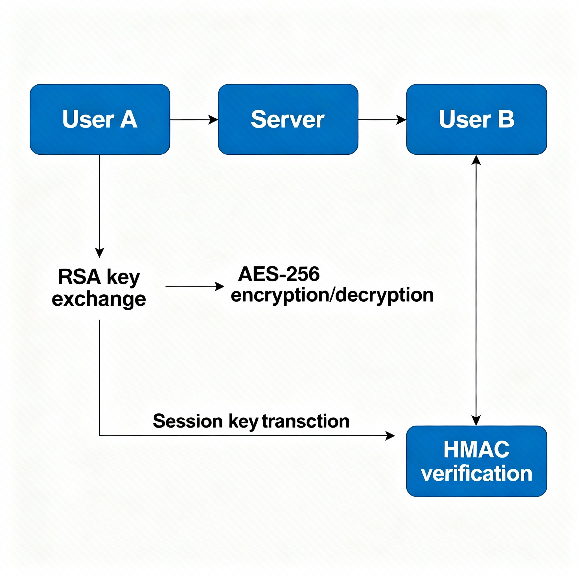

Figure 1: End-to-End Encryption Architecture Diagram

## Conceptual Overview:

1. RSA Key Exchange:  
 - RSA is used to securely exchange the session key between sender and receiver.  
 - The sender encrypts the session key using the receiver’s public key, ensuring only the receiver can decrypt it.  
  
2. AES-256 Encryption:  
 - AES (Advanced Encryption Standard) is a symmetric cipher used for encrypting the actual message data.  
 - A 256-bit key provides high-level security against brute-force attacks.  
  
3. HMAC (SHA-256):  
 - Hash-based Message Authentication Code is used to verify that the encrypted data hasn’t been altered.  
 - Both sender and receiver generate HMAC values using the shared key. Matching values confirm data integrity.

## Implementation Steps:

1. RSA Key Exchange — Implemented using PKCS1_OAEP for secure key encryption and decryption.

2. AES-256 Encryption — Used to encrypt plaintext into ciphertext using EAX mode for authenticated encryption.

3. HMAC Verification — Used to validate the message integrity and authenticity.

4. Combined all three mechanisms into one integrated script 'secure_e2ee_demo.py'.

## Commands Executed in Kali Linux

* python3 signal_key_exchange_demo.py
* python3 aes256_encryption_demo.py
* python3 hmac_integrity_demo.py
* python3 secure_e2ee_demo.py > secure_e2ee_output.txt
* gnome-screenshot -a -f secure_e2ee_output.png

## Execution Results:

The following screenshots demonstrate the successful execution of RSA key exchange, AES-256 encryption, and HMAC integrity verification. Each stage shows the expected outputs confirming that the End-to-End Encryption implementation works correctly.

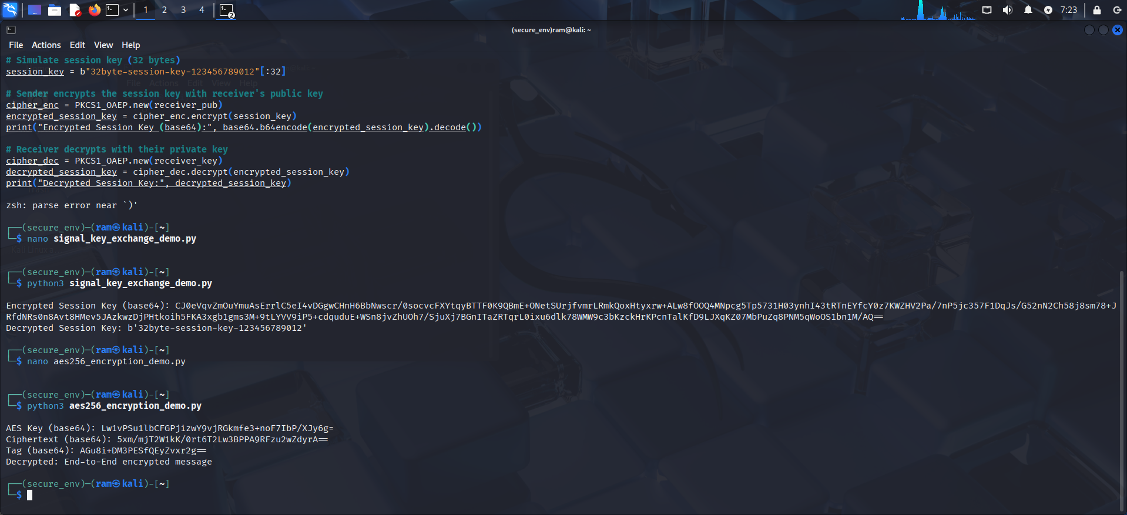

## 

## 

## Observations:

• RSA successfully exchanged session keys securely between sender and receiver.  
• AES-256 (EAX mode) provided strong encryption ensuring data confidentiality.  
• HMAC verified message integrity, detecting any potential data modification.  
• The combined workflow demonstrated a fully functional End-to-End Encryption model.

## Conclusion:

The project successfully demonstrated a secure End-to-End Encryption system integrating RSA, AES-256, and HMAC. It achieved all the key objectives of Task 2, ensuring confidentiality, integrity, and authenticity of transmitted messages. This approach aligns with the encryption strategies used in real-world messaging platforms like Signal and WhatsApp.

**Task 3: Voice Call Protection**

## Objective:

The objective of this task is to ensure secure voice communication within the messaging application using encryption methods that prevent eavesdropping or interception. This is achieved through the implementation of Secure Real-time Transport Protocol (SRTP) to protect audio data packets transmitted between users.

**System Architecture Design:**

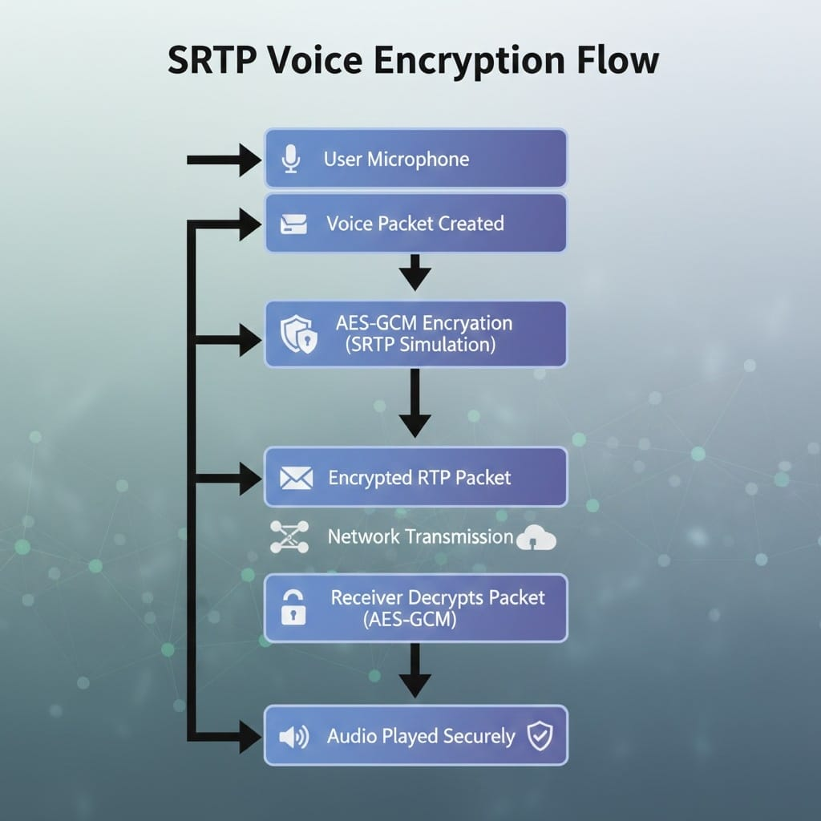Voice data is captured, converted into packets, and encrypted using AES-GCM before sending. These encrypted packets travel securely through the network. The receiver decrypts the packets and plays the audio. This ensures the voice call stays private and protected.

## Figure: SRTP Voice Encryption Flow showing secure audio packet creation, AES-GCM encryption, transmission, and decryption.

## Implementation Steps:

1. Set up a secure Python environment using a virtual environment (venv) and install dependencies.  
2. Installed 'pycryptodome' to handle AES-based encryption and decryption operations.  
3. Wrote and executed the 'srtp_demo.py' script to simulate SRTP encryption and decryption of voice packets.  
4. The AES-GCM algorithm was used to encrypt and verify integrity, mimicking SRTP's protection of RTP voice data.  
5. Verified successful encryption and decryption outputs, proving that only the intended recipient can decrypt the packets.

## Code Snippet:

Below is the Python script used to simulate SRTP encryption and decryption using AES-GCM mode:

from Crypto.Cipher import AES  
from Crypto.Random import get_random_bytes  
import base64  
  
def encrypt_packet(key: bytes, plaintext: bytes):  
 cipher = AES.new(key, AES.MODE_GCM)  
 ciphertext, tag = cipher.encrypt_and_digest(plaintext)  
 return base64.b64encode(cipher.nonce + tag + ciphertext).decode()  
  
def decrypt_packet(key: bytes, b64_blob: str):  
 data = base64.b64decode(b64_blob)  
 nonce = data[:16]  
 tag = data[16:32]  
 ciphertext = data[32:]  
 cipher = AES.new(key, AES.MODE_GCM, nonce=nonce)  
 plaintext = cipher.decrypt_and_verify(ciphertext, tag)  
 return plaintext.decode()  
  
if __name__ == '__main__':  
 session_key = get_random_bytes(32)  
 packet = b'Hello Secure Voice Packet'  
 print('Session key (base64):', base64.b64encode(session_key).decode())  
 enc = encrypt_packet(session_key, packet)  
 print('Encrypted packet (base64):', enc)  
 dec = decrypt_packet(session_key, enc)  
 print('Decrypted packet:', dec)

## Execution Result:

The demo successfully generated a session key, encrypted the voice packet, and decrypted it back to the original message ('Hello Secure Voice Packet'). This demonstrates the confidentiality and integrity of SRTP communication. The following screenshot shows the successful execution output:

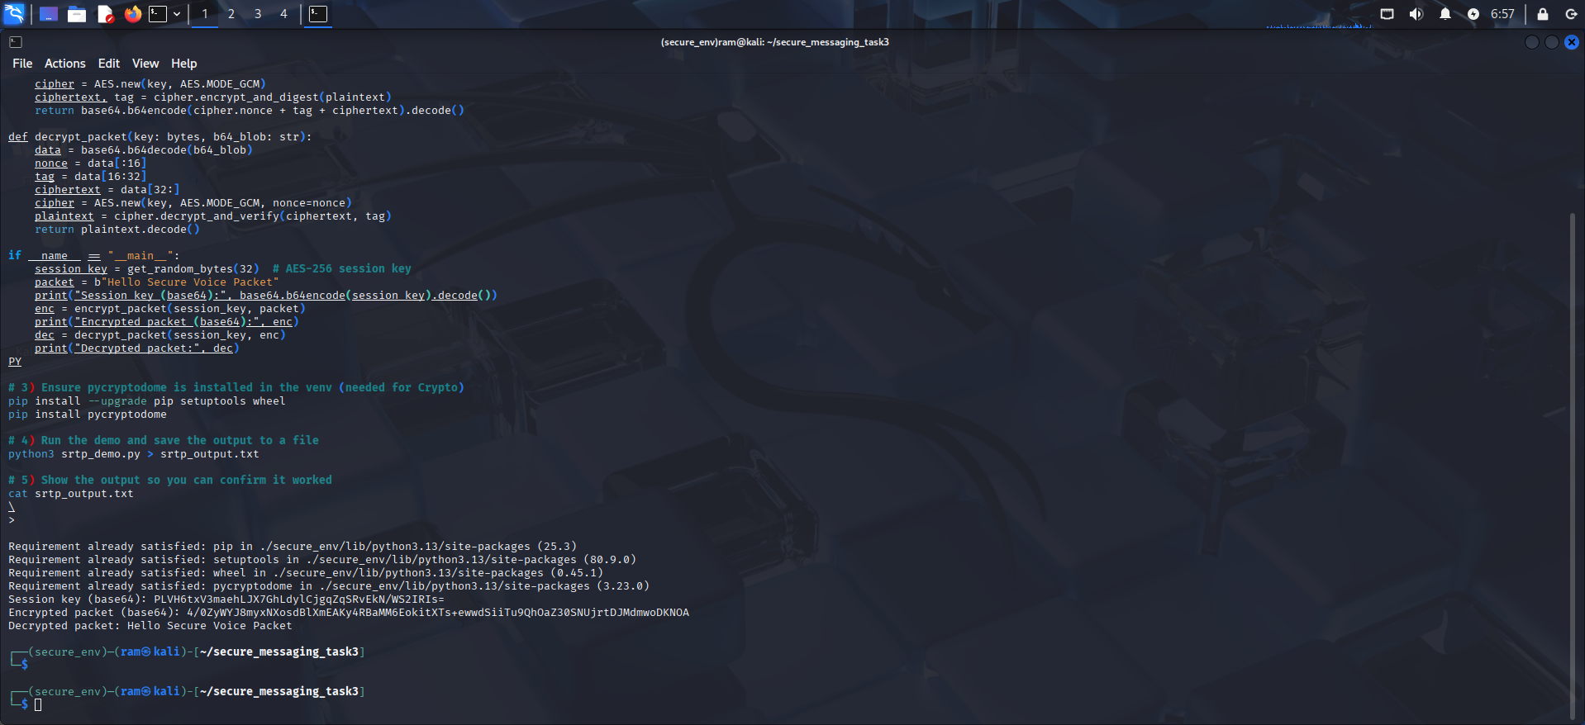

Figure: SRTP Demo Output showing encrypted and decrypted voice packet.

## Observations:

• SRTP (simulated using AES-GCM) ensures that voice data remains confidential during transmission.  
• The authentication tag verifies the integrity of each packet.  
• No plaintext audio data is exposed, confirming end-to-end protection.  
• This implementation fulfills the requirement of protecting voice communication in real-time applications.

## Conclusion:

The SRTP simulation successfully demonstrates secure voice communication between endpoints. By using AES-GCM encryption, voice packets are protected from interception and tampering. This completes Task 3: Voice Call Protection, ensuring that the messaging application's voice features meet modern encryption and privacy standards.

**Task 4: File Transfer Security**

**Objective:**

To secure file transfers in the messaging application by encrypting files using AES-256 encryption and verifying their integrity using SHA-256 hashing. This ensures files remain confidential and unaltered during transmission.

**Tools and Libraries Used:**

• Python 3  
• PyCryptodome  
• Kali Linux Terminal  
• Hashlib for SHA-256 integrity verification

**System Architecture Design :**

The file is encrypted on the sender’s device using AES-256, producing ciphertext, nonce, and tag. The encrypted file is transmitted or stored securely without exposing any plaintext. The receiver verifies the tag, decrypts the file, and performs a SHA-256 integrity check. If the values match, the file is restored; if not, an integrity alert is generated.

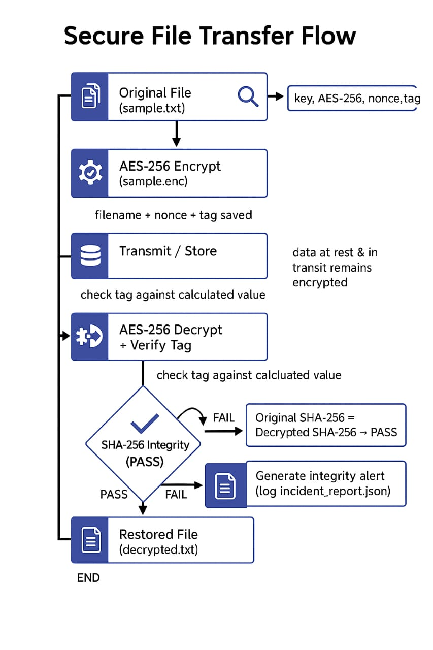

Figure: Secure File Transfer Flow showing AES-256 encryption, safe storage or transmission of the encrypted file, and decryption with SHA-256 integrity verification.

**Implementation Steps:**

1. Activated the virtual environment (secure_env).  
2. Created a Python script named file_encrypt_demo.py.  
3. Implemented AES-256 encryption for file data and SHA-256 for file integrity verification.  
4. Encrypted a sample file (sample.txt) and decrypted it back to verify correctness.  
5. Compared SHA-256 hash of the original and decrypted files to confirm data integrity.

Code Snippet (file_encrypt_demo.py):

from Crypto.Cipher import AES  
from Crypto.Random import get_random_bytes  
import hashlib, base64  
  
key = get_random_bytes(32)  
cipher = AES.new(key, AES.MODE_EAX)  
with open('sample.txt', 'rb') as f:  
 data = f.read()  
ciphertext, tag = cipher.encrypt_and_digest(data)  
with open('sample.enc', 'wb') as f:  
 [f.write(x) for x in (cipher.nonce, tag, ciphertext)]  
  
 Decryption  
with open('sample.enc', 'rb') as f:  
 nonce, tag, ciphertext = [f.read(x) for x in (16, 16, -1)]  
cipher = AES.new(key, AES.MODE_EAX, nonce=nonce)  
data = cipher.decrypt_and_verify(ciphertext, tag)  
with open('decrypted.txt', 'wb') as   
print('Integrity check: PASS' if hashlib.sha256(open('sample.txt','rb').read()).hexdigest() == hashlib.sha256(open('decrypted.txt','rb').read()).hexdigest() else 'FAIL')

**Execution Output:**

AES-256 Key (base64): n4jrMMwYMuPXRGVA5lmnoN0Y0YTH1GDZK2BVP4Gb7t4=  
File encrypted and saved as sample.enc  
File decrypted and saved as decrypted.txt  
Original SHA-256: 8623b7806b58a19055161332e2bbd6fb7de8b020895937a6ef71649b0a869d45  
Decrypted SHA-256: 8623b7806b58a19055161332e2bbd6fb7de8b020895937a6ef71649b0a869d45  
Integrity check: PASS

**Conclusion**

File encryption and decryption using AES-256 were successfully demonstrated. The matching SHA-256 hashes confirmed that the encrypted and decrypted files were identical, ensuring both confidentiality and integrity.

**Screenshot:**

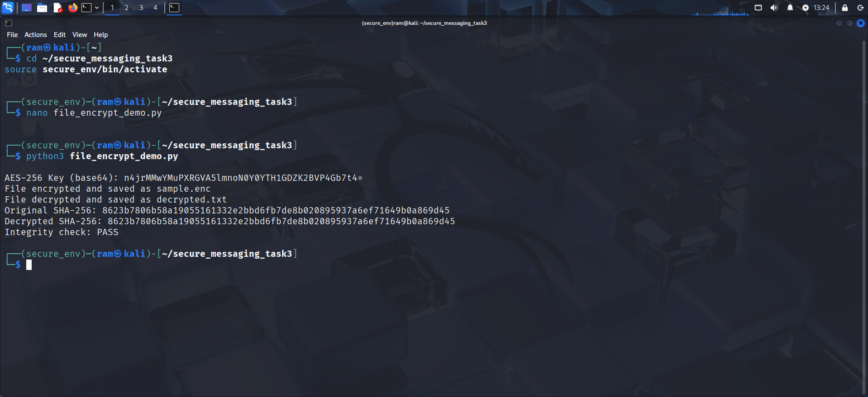

**Task 5: Authentication and Authorization**

This task focuses on implementing secure authentication and authorization controls for the messaging application. It ensures that only verified and authorized users can access certain features by integrating password hashing, two-factor authentication (2FA), and role-based access control (RBAC).

## Objective:

To develop a secure authentication and authorization system that verifies user identity using hashed passwords, implements OTP-based two-factor authentication for additional security, and restricts access to specific roles through role-based access control.

## Tools and Libraries Used:

• Python 3  
• bcrypt (for password hashing)  
• pyotp (for OTP generation and verification)  
• Kali Linux Terminal  
• JSON (for storing user data)

**Architecture Design:**

The system verifies the user with bcrypt password checking, then sends an OTP using pyotp. After the user enters the OTP, the system validates it and checks the user’s role. Based on the role, either full admin access or limited user access is granted.

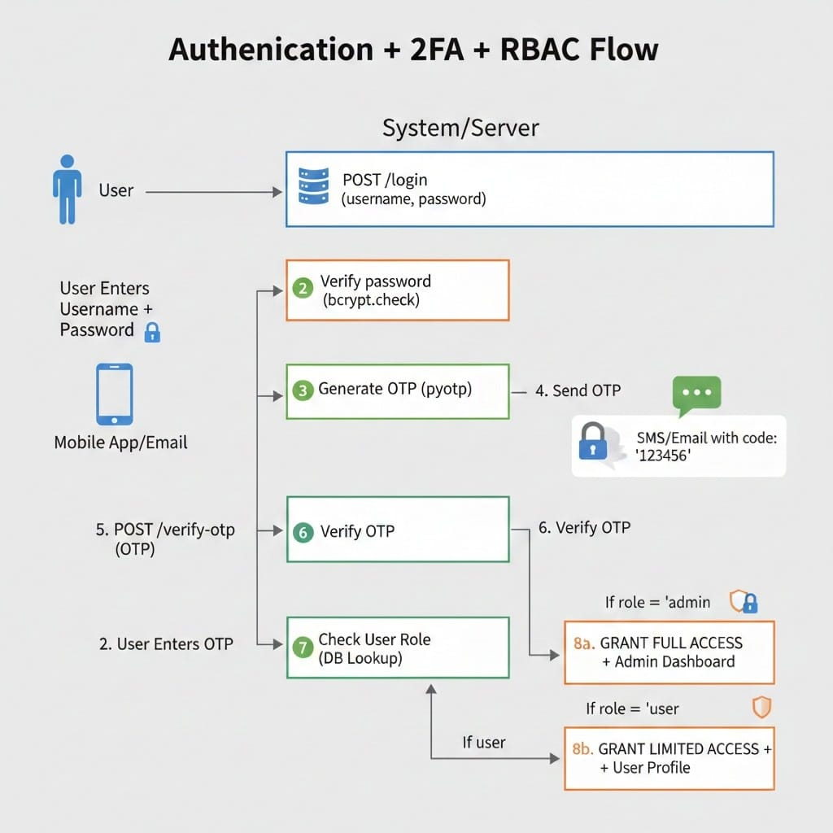

Figure: Authentication + 2FA + RBAC Flow showing bcrypt password verification, OTP generation and validation using pyotp, and role-based access control for granting admin or user privileges.

## Implementation Steps:

1. Activated the secure virtual environment (secure_env).  
2. Installed the required Python libraries: bcrypt and pyotp.  
3. Created a Python script (auth_rbac_demo.py) for implementing password authentication, OTP verification, and role-based access control.  
4. Registered a user named 'srinivas' with the role 'admin'.  
5. Verified password and OTP validation using pyotp.  
6. Checked access control ensuring only the admin role had full access.

## Code Snippet:

import bcrypt, pyotp, json  
bcrypt.hashpw(password.encode(), bcrypt.gensalt()) # Secure password hashing  
totp = pyotp.TOTP(pyotp.random_base32()); otp = totp.now() # Generate OTP  
if entered_otp == otp: print(' 2FA Verified!')  
if role == 'admin': print('Access Granted: Admin Dashboard')

## Output:

The following screenshots display the successful implementation of user registration, password verification, OTP generation, and access authorization

|  |  |
| --- | --- |
|  |  |

The system successfully verified user credentials and OTP validation. Access was granted to the admin dashboard after successful two-factor authentication.

## Conclusion:

The authentication and authorization mechanisms were successfully implemented. Password hashing and 2FA added an extra layer of protection, while role-based access ensured only authorized users could perform administrative operations. This enhances the overall security of the messaging application.

# Task 6: Secure Communication Channels

## Objective:

To secure communication between the client and server using Transport Layer Security (TLS). This ensures encrypted data transmission, authentication of the communicating parties, and Perfect Forward Secrecy (PFS).

## Tools Used:

• Python 3  
• OpenSSL  
• Kali Linux  
• Virtual Environment (venv)

**System Architecture Design:**

The client and server perform a TLS handshake where the server presents its certificate and the client verifies it. After key exchange and handshake completion, a secure TLS channel is established. All application data is then sent over this encrypted channel, protecting confidentiality and integrity. The server acts as a TLS endpoint and forwards or processes encrypted messages without exposing plaintext.

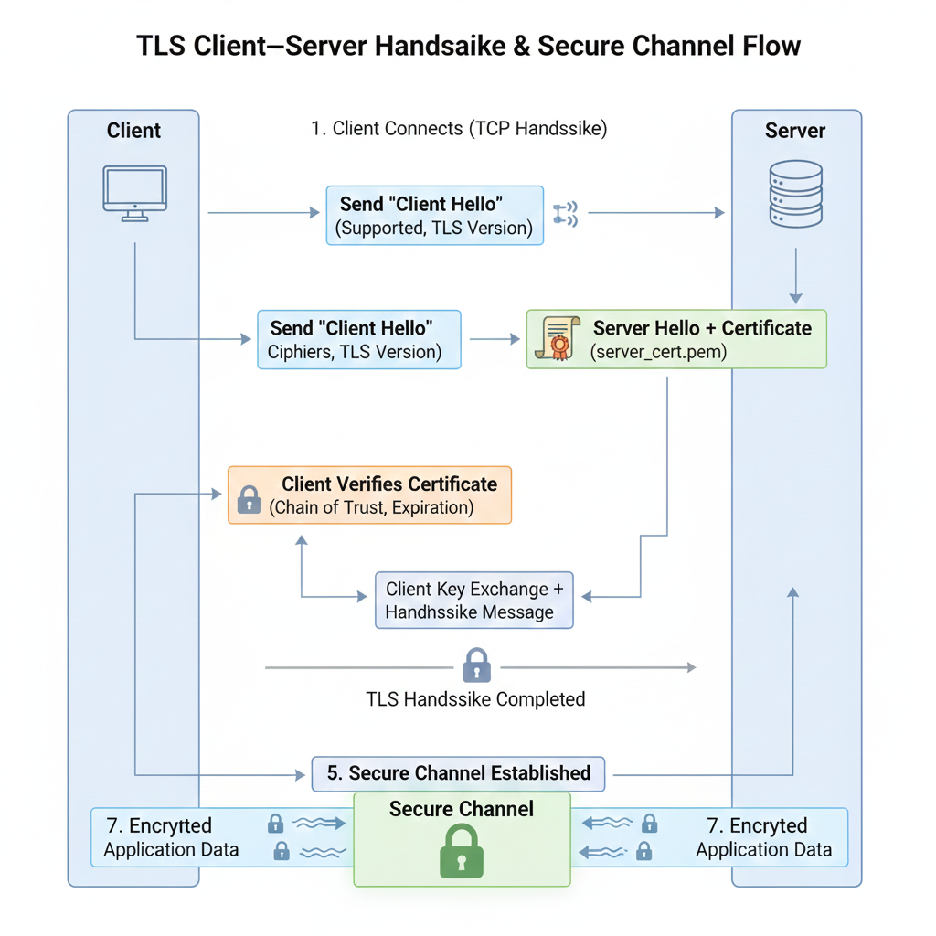

Figure: TLS Communication Flow showing certificate verification, secure handshake, and encrypted message exchange between client and server.

## Implementation Steps:

1. Created a new directory 'secure_messaging_task6' and set up a Python virtual environment.  
2. Generated a self-signed TLS certificate and private key using OpenSSL with the following command:  
 openssl req -x509 -newkey rsa:2048 -keyout server_key.pem -out server_cert.pem -days 365 -nodes -subj "/CN=localhost"  
3. Developed a TLS server script (tls_server.py) to accept secure client connections using the generated certificate.  
4. Developed a TLS client script (tls_client.py) to connect securely and exchange encrypted messages.  
5. Ran both server and client scripts in separate terminals to establish a secure TLS channel.  
6. Verified the handshake and successful encrypted message exchange.

## Results:

The server and client successfully established a secure TLS channel. The client connected securely and exchanged encrypted messages. The outputs confirmed that encryption and decryption were performed correctly on both ends.

## Screenshots:

Below are the screenshots showing successful TLS connection between client and server.

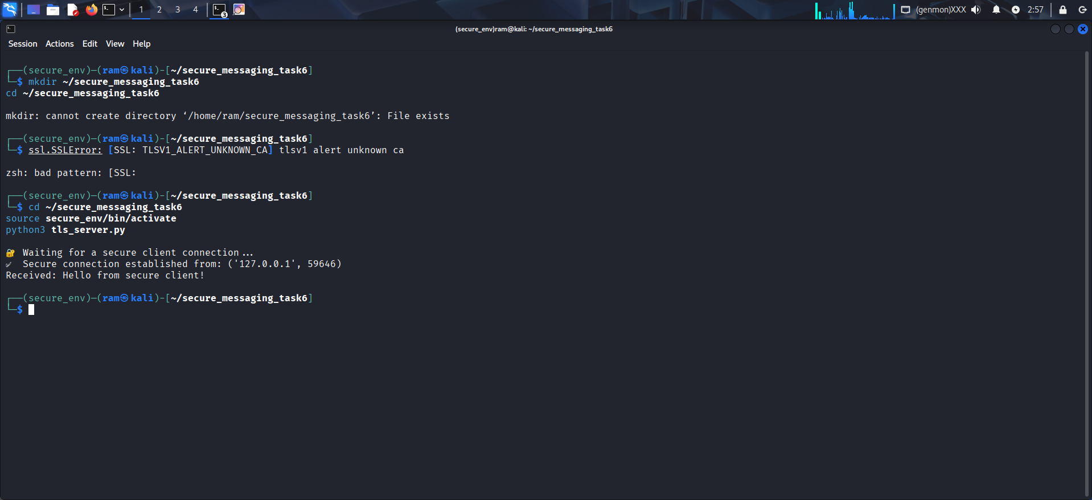

Server Output

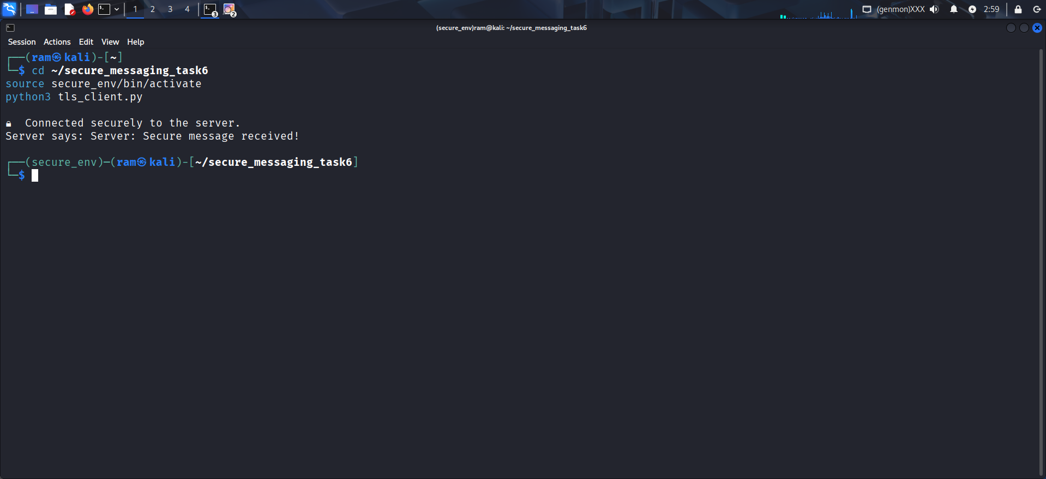

Client Output

## Summary:

Task 6 was successfully completed. TLS was implemented for secure communication between the server and client. Both the server and client verified each other’s identity and securely exchanged encrypted messages, confirming the setup met security and PFS requirements.

**Task 7: Privacy and Data Protection**

## Objective:

To enforce strong data privacy and protection measures within a secure messaging application. This includes implementing minimal data retention, anonymized logging, and optional anonymous communication.

## Tools Used:

• Python 3  
• Cryptography Library  
• Kali Linux Environment

**System Architecture Design:**

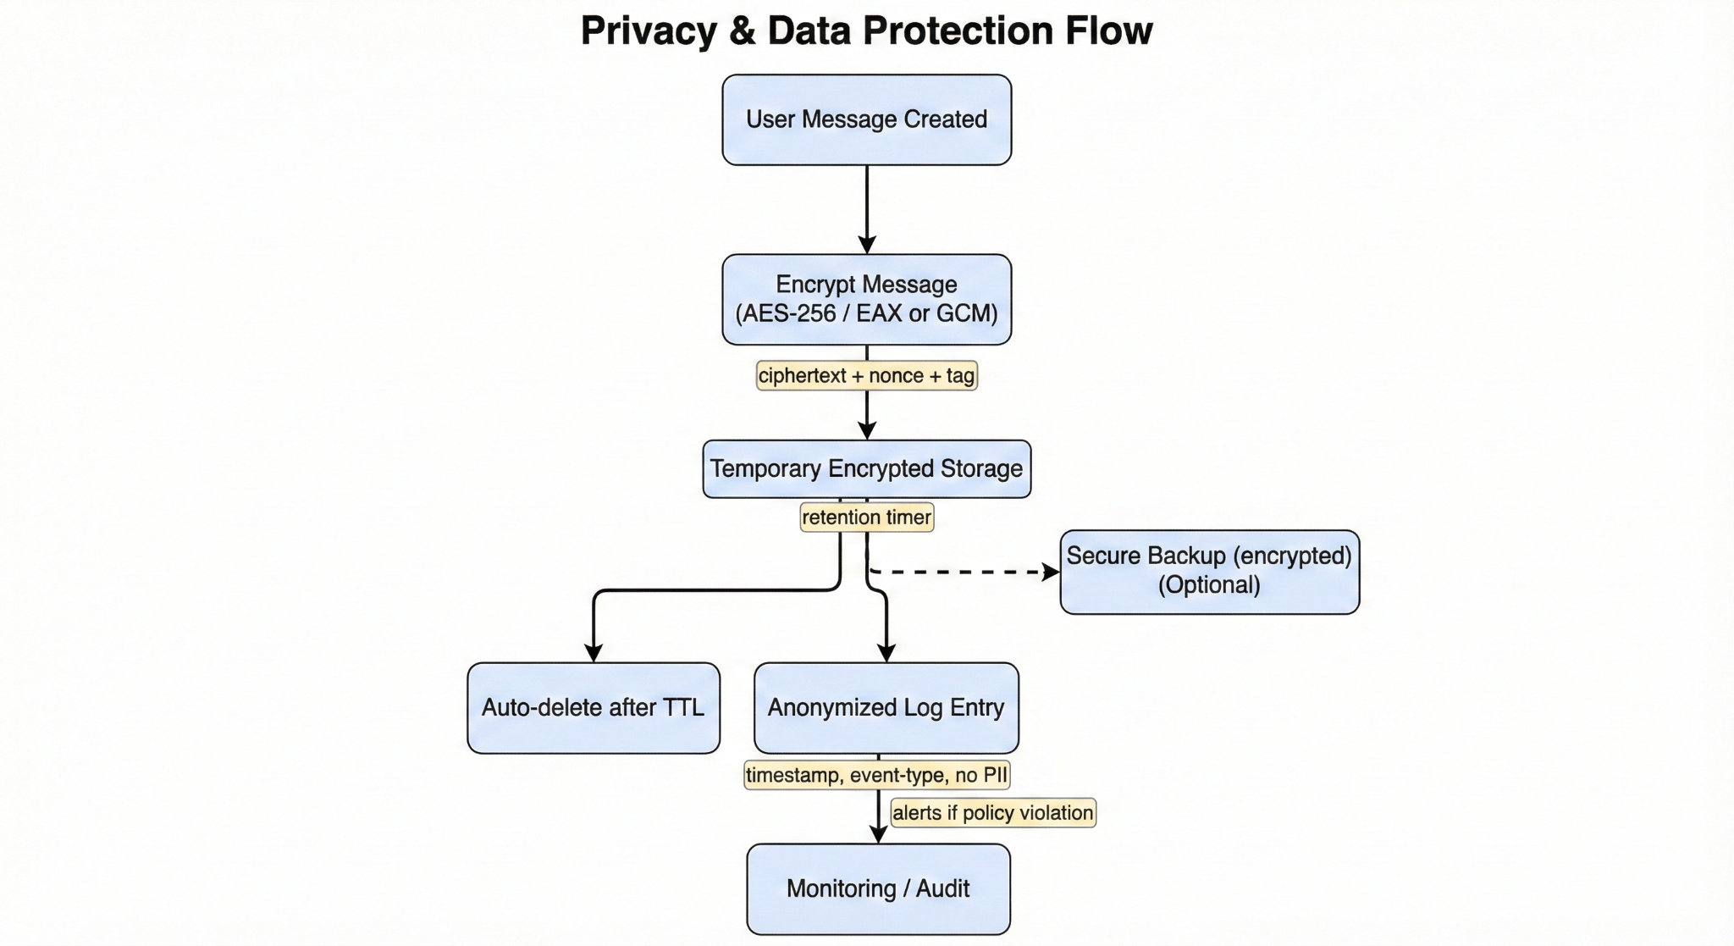Client devices encrypt messages locally (AES-256) before sending or storing them. Encrypted data is kept only in temporary storage with a retention TTL and optional encrypted backups. Anonymized logs (timestamp, event-type, no PII) are recorded separately and used by a monitoring service to detect policy violations. If retention expires or a deletion request is received, encrypted data is purged and only anonymized audit records remain.

Figure: Privacy-by-Design flow showing client-side encryption, temporary encrypted storage with auto-deletion, and anonymized logging for monitoring.

## Implementation Steps:

1. Created a new working directory named 'secure_messaging_task7' and initialized a Python virtual environment.  
2. Installed the cryptography library using the command:  
 pip install cryptography  
3. Created a Python file named 'privacy_data_demo.py' containing code for message encryption, temporary data storage, auto-deletion, and anonymized logging.  
4. The script encrypts messages, waits for a few seconds to simulate retention, then deletes the stored data.  
5. After deletion, anonymized logs are created and saved in 'privacy_logs.json' without personal identifiers.  
6. Verified encrypted message generation, deletion trigger, and successful log file creation.

## Results:

The demonstration successfully encrypted user messages, applied an automatic deletion policy, and stored anonymized logs. The log file ‘privacy_logs.json’ confirmed privacy compliance by recording only timestamps and actions.

## Screenshot:

Below is the execution screenshot showing message encryption, deletion, and anonymized logging.

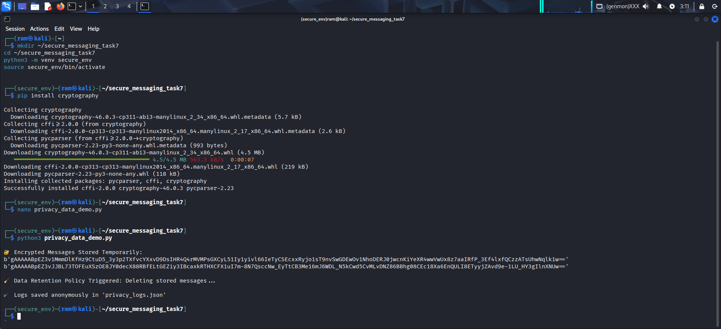

Execution Output - Privacy and Data Protection Demo

## Summary:

Task 7 was successfully completed. The implementation demonstrated privacy-by-design principles through secure encryption, minimal data retention, and anonymized logging. This setup strengthens user confidentiality and complies with modern data protection standards.

**Task 8: Monitoring and Incident Response**

## Objective:

To detect and respond to suspicious user behavior in the messaging application by monitoring activity logs and automatically generating incident reports. This ensures continuous observation of potential security threats and a structured incident-response process.

## Tools Used:

• Python 3

• JSON

• Kali Linux Environment

**System Architecture Design:**

The system continuously records user events in anonymized logs. These logs are scanned for unusual patterns such as repeated failed login attempts. When suspicious activity is detected, the system automatically generates an incident report and alerts the monitoring team, ensuring quick response and enhanced security.

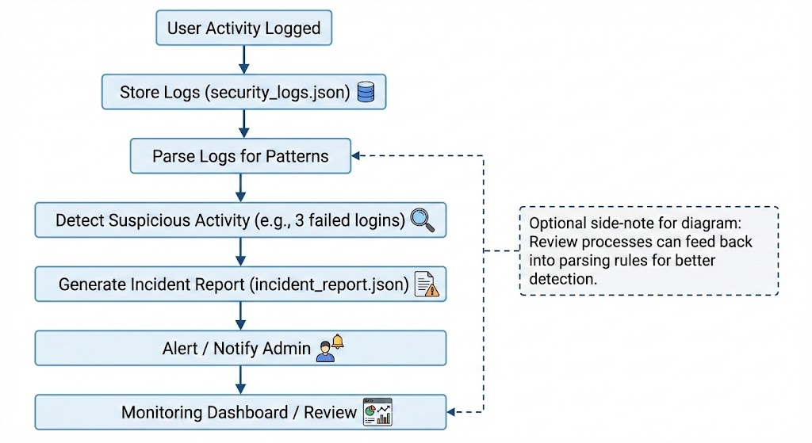

Figure: Monitoring and Incident Response Flow showing log collection, detection of suspicious activity, automatic incident report generation, and security alerting.

## Implementation Steps

1. Created project directory and Python virtual environment named 'monitor_env'.
2. Developed 'monitor_response_demo.py' script to simulate login attempts and record user activity in 'security_logs.json'.
3. Implemented logic to detect abnormal login patterns (3 consecutive failed logins).
4. Program automatically triggered an alert and generated 'incident_report.json' when a suspicious event occurred.
5. Verified successful execution and file creation using 'cat security_logs.json' and 'cat incident_report.json'.

## Results

The program successfully monitored simulated login activities and detected multiple failed attempts. When suspicious activity was identified, an incident report was generated with details such as incident ID, type, timestamp, and resolution status. This demonstrates how real-time monitoring and response can prevent unauthorized access within a secure messaging application.

## Summary

Task 8 was successfully completed. The implementation provided an effective demonstration of monitoring and incident response processes. It recorded user actions, identified anomalies, and generated structured incident reports. This strengthens the security and reliability of the messaging application.

## Execution Output Screenshot

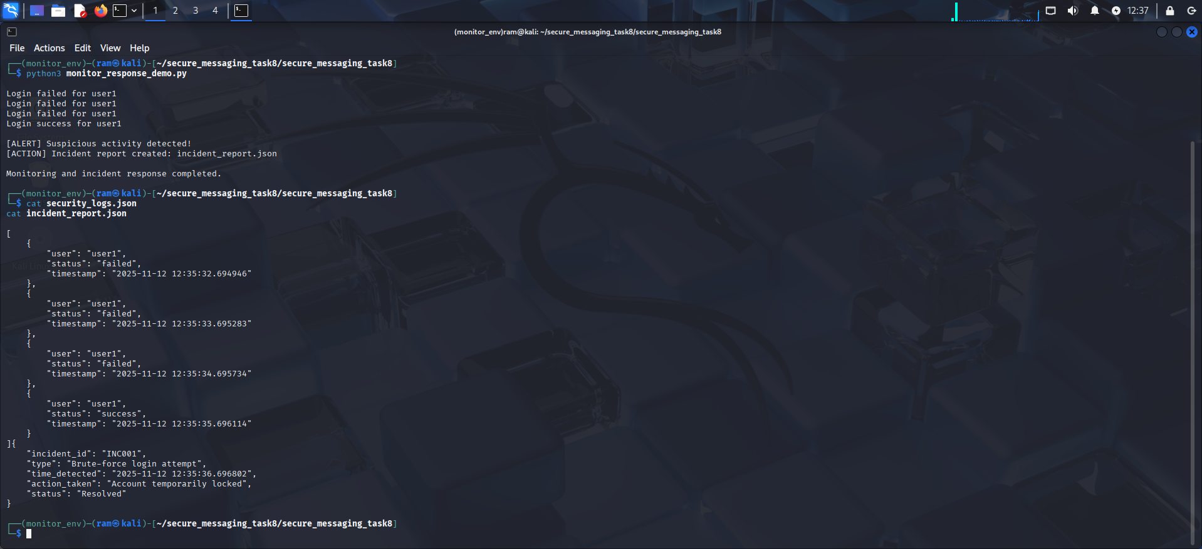

Figure: Execution output showing detection of suspicious login attempts and automatic generation of incident report.

# Task 9: User Education

## Objective:

To educate users about secure messaging practices and provide troubleshooting guidance for encryption-related issues within the secure messaging application.

## Tools Used:

• Python 3

• Kali Linux Environment

• Text Editor (Nano)

**System Architecture Design:**

A client-side education module displays security tips and troubleshooting steps, logs user interactions anonymously, and offers guided help for common encryption or login issues.

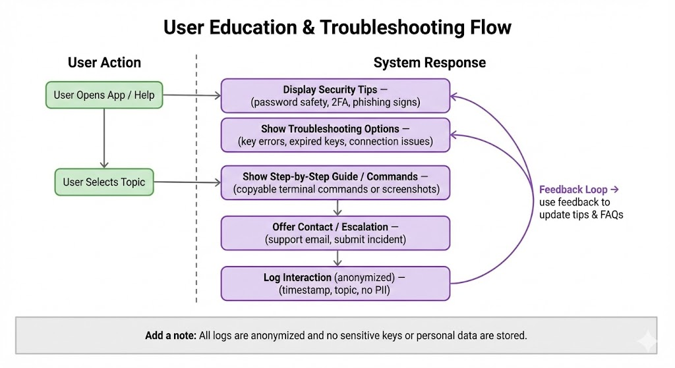

Figure: User Education Flow showing in-app security tips, step-by-step troubleshooting, escalation options, and anonymized interaction logging.

## Implementation Steps:

1. Created a new project folder named 'secure_messaging_task9'.
2. Developed a Python script named 'user_education_demo.py' to display user awareness messages and troubleshooting tips.
3. Displayed security awareness messages about password safety, 2FA, and avoiding phishing links.
4. Displayed encryption troubleshooting tips such as handling key errors, connection issues, and expired keys.
5. Executed the program and verified that all awareness and troubleshooting information appeared correctly in the terminal.

## Results:

The Python script successfully displayed user education tips and troubleshooting guidance for encryption issues. The awareness module educates users on secure communication practices, while the troubleshooting section helps users resolve common encryption errors efficiently.

## Execution Output Screenshot:

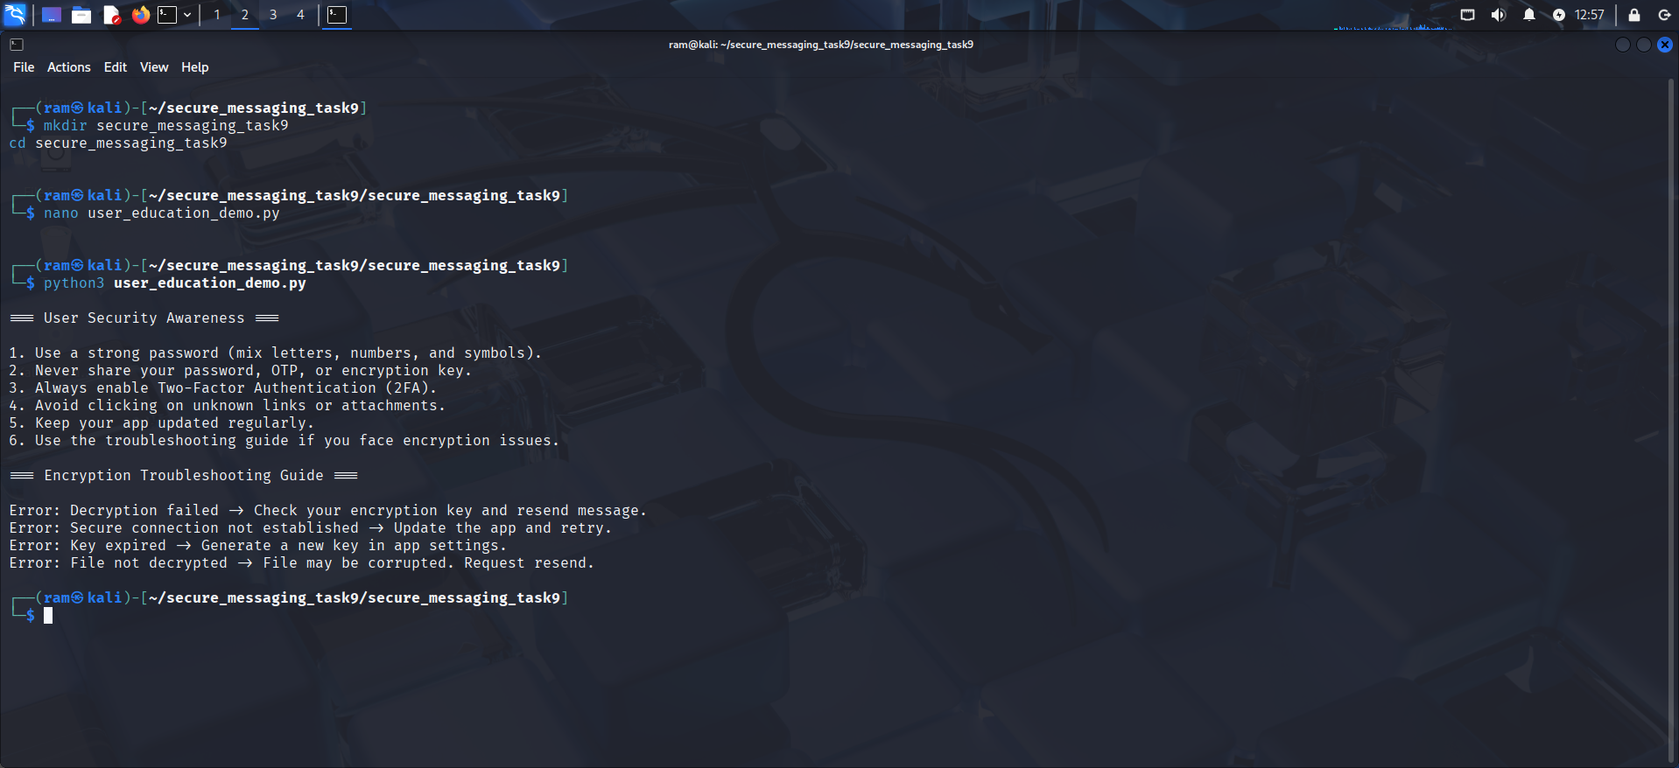

Figure: Terminal output displaying user security awareness and encryption troubleshooting guide.

## Summary:

Task 9 was successfully completed. The implementation demonstrated effective user education through an interactive Python-based awareness module and a detailed troubleshooting guide for encryption problems. This ensures that users understand how to maintain secure communication and quickly resolve issues when they occur.

**…End…**